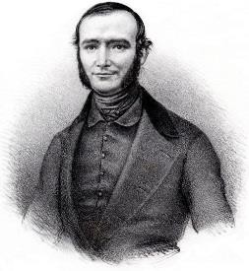
PERDIGUIER PROGRAMME
2021-2022
Support for international mobility for the University of Avignon doctoral students

Application form

1st session
File to be submitted to gestion-ed@univ-avignon.fr before 3 November 2021

Document to be attached to the file:

- A letter of invitation from the host research laboratory
- Proof of funding of the thesis from the funding organisation

- Information about the candidate and the current PhD
Surname:
Married name if applicable:
First name:
Title of the thesis:

Number of registrations for the diploma:
Doctoral diploma:
Doctoral school of affiliation: ⇨ 536 ⇨ 537
Type of funding:
Research laboratory:
Name of the main thesis supervisor (and possible co-supervisor) at the University of Avignon:

- International mobility project

Expected duration of stay in months:
Start date of stay (DD / MM / YY): / /
End date of stay (DD / MM / YY): / /
Name of the host institution:
Address:
Postcode: City: Country:

Name of host research laboratory:
Name of the director of the host research laboratory:
E-mail of the director of the host research laboratory:

Summative description of the mobility project showing its potential contribution to the doctoral student's research and professional project:

CV elements (previous training, professional experience, publications....)

Opinion of the main thesis supervisor:

- Financing of the trip
- Have you already applied for the Perdiguier grant? YES NO
If so, when?
- Have you already benefitted from the Perdiguier grant? YES NO
If so, when?
- Do you benefit from other mobility assistance? YES NO
If so, which ones and how much?
- Will your current resources continue to be paid for during your stay abroad?
YES NO

Mobility budget - indicate here the total amount of support requested:
Please pay attention to the balance of the budget presented (expenditure and income)

EXPENDITURE |  | INCOME
Nature | Amount | Origin | Amount
Travel:  Accommodation:  Other costs (please specify): |  | Acquired (please specify):  Requested:  - AAP Perdiguier  - Other (please specify)
TOTAL 1 |  | TOTAL 2

The doctoral student | The UofA thesis supervisor
Date: / _ / | Date: / _ /
(signature) | (signature)

